**CHAPTER-1**

**INTRODUCTION**

**ORGANISATION OVERVIEW**

**1.1 INTRODUCTION**

**Cognizant** is an American multinational corporation that provides IT services, including digital, technology, consulting, and operations services. It is headquartered in Teaneck, New Jersey,United States of America. Cognizant is included in the NASDAQ-100 and the S&P 500 indices. It is also one of the fastest growing Fortune 500 companies. It was founded as an in-house technology unit of DUN & BRADSTREEIN in 1994, and started serving external clients in 1996.

Cognizant had a period of fast growth during the 2000s, becoming a Fortune 500 company in 2011. In 2015, the FORTUNE Magazine named it as the world's fourth most admired IT Services company. In 2017, Cognizant was named in Fortune’s Future 50 list.

Cognizant provides information technology, information security, consulting, ITO and BPO services. These include business & technology consulting, system integration, application development & maintenance, IT infrastructure services, analytics, business intelligence data , warehousing, customer relationship management, supply chain management, engineering & manufacturing solutions, enterprise resource planning, research and development, outsourcing, and testing solutions.

Cognizant has three key practice areas that span its business — Digital Business, Digital Operations, and Digital Systems & Technology.

The company is split into two new major services, Nelson Media Research, and IMS Health. After some time, it became the public subsidiary of the IMS Health. But in 2003, Cognizant sold all its shares in the subsidiary and the CEO also resigned from his post. The company expanded its work from IT services to Outsourcing and business consulting as well. There was a fast growth in the success of Cognizant. The services provided include application development, business intelligence, supply chain management, CRM, etc

Cognizant also follows a global model for delivery. There are many offshore offices of the companies span over many countries in the world. The main sources of business for the company were the American as well as European clients. The company is a provider of high-end services in all fields. It is one of the top 10 companies that are legitimate in bringing the employee on H-1B into the US.

The company also has plans to increase its US business operations in the coming years. A total of 50 recruiters is continually hiring in the United States for different positions in the US itself. The company has nine delivery centres in the United States, Bridgewater, New Jersey; Phoenix, Arizona, Des Moines Iowa, etc.

Cognizant houses around 150,000 employees and has spanned all over the world. There are many development centres of the company as well. There are many units which are divided into vertical and horizontal sections. The vertical unit is for Healthcare, Retail, Banking Services, whereas the horizontal unit focuses on mobile computing, testing, and BPO. More than 100,000 employees work in India. The major revenue of the company is from financial companies and then from healthcare industries.

The company also launched the Go Green initiative in the year 2008. This cause completely focused on recycling, waste management, and energy conservation.Cognizant is the 50th traded companies in the United States.

**1.1 Purpose**

This document is aimed at :

• Providing the necessary inputs to the detailed requirements gathering phase and further on for the SDLC processes.

• This document also serves to establish the traceability between the Business Objectives and the requirements identified in the proposed solution and how they satisfy the stated objectives.

• Provide expectation traceability in terms of the requirements and the user expectation

• Serves as a formal template for documenting the Business Requirements which also includes statutory and regulatory requirements.

The purpose of this document is to systematically capture the requirements of the project and the system to be developed. The document also captures the Functional requirements and serves as an input for the scope of project.

* 1. **Objective**

1. Enables the Patients and Doctors to be connected on the go.

2. Allows discovery, and retrieval of the available doctors along with their specialization.

3. Automated scheduling of appointments.

4. Reminder for followups/checks.

5. Online chat facility for Doctors and Patients.

**1.2 Motivation**

This project was chosen with idea of automation to quickly connect doctors and patient so that the Users can use this portal easily and efficiently and can easily get notified by any updates from the admin .The proposed system should provide various features for user benefits so that user can easily book their appointments with the doctor.

**1.3 Definition and overview**

The ‘Health Inspector’ is a web based application. ‘Health Inspector’ is the name given to the web portal.

Features of this web-application are as follows:

* Create an automated system to effectively track and manage the Patient’s appointment scheduling and checkup reminders.
* User will get doctor details by searching from search page for specific field of treatment.
* Allows discovery, and retrieval of the available doctors along with their specialization.
* Automated scheduling of appointments and reminders for followups/checkups.
* Online chat facility for Doctors and Patients.

**CHAPTER-2**

**SYSTEM DEVELOPMENT LIFE CYCLE MODEL**

**2.1 Introduction**

The systems development life cycle (SDLC) is a conceptual model used in project management that describes the stages involved in an information system development project, from an initial feasibility study through maintenance of the completed application.

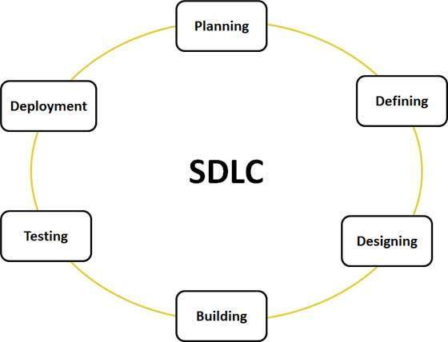

Fig.2.1.1. SDLC cycle

**2.2 Feasibility Study**

Depending on the results of the initial investigation, the survey is expanded to a more detailed feasibility study. Feasibility study is a test of system proposal according to its work ability, impact on the organization, ability to meet user needs, and effective use of resources. The objective for this phase is not to solve the problem but to acquire a sense of scope. During the study, the problem definition is crystallized and aspects of the problem to be included in the system are determined. We started the project by listing the possible queries that the user might want to be satisfied. And on these lines we guided the project further.

The three main points, kept in mind at the time of project are:

* Resource Availability (To build it with the given technology and resources)
* Affordable (Given the time and cost constraints of the organization)
* Acceptable (For use by the eventual users of the system

The three major areas to be considered while determining the feasibility of a project are:

* Economic Feasibility
* Technical Feasibility
* Behavioral Feasibility

**2.2.1 Economic Feasibility**

A system can be developed technically and that will be used if installed must still be a good investment for the organization. In the economical feasibility, the development cost in creating the system is evaluated against the ultimate benefit derived from the new systems.

Financial benefits must equal or exceed the costs. The system is economically feasible. It does not require any addition hardware or software. Since the interface for this system is developed using the existing resources and technologies, there is nominal expenditure and economical feasibility for certain.

**2.2.2 Technical Feasibility**

The technical issue usually raised during the feasibility stage of the investigation includes the following:

* Does the necessary technology exist to do what is suggested?
* Do the proposed equipment’s have the technical capacity to hold the data required to use the new system?
* Will the proposed system provide adequate response to inquiries, regardless of the number or location of users?
* Can the system be upgraded if developed?
* Are there technical guarantees of accuracy, reliability, ease of access and data security?

Earlier no system existed to cater to the needs of ’Secure Infrastructure Implementation System. The current system developed is technically feasible. It is a web based user interface. Thus it provides an easy access to the users. The databases purpose is to create, establish and maintain a workflow among various entities in order to facilitate all concerned users in their various capacities or roles. Permission to the users would be granted based on the roles specified.

Therefore, it provides the technical guarantee of accuracy, reliability and security. The software and hardware requirements for the development of this project are not many and are already available as free as open source. The work for the project is done with the current equipment and existing software technology. Necessary bandwidth exists for providing a fast feedback to the users irrespective of the number of users using the system.

**2.2.3 Behavioral Feasibility**

Proposed projects are beneficial only if they can be turned out into information system that will meet the organizations operating requirements. Behavioral feasibility aspects of the project are to be taken as an important part of the project implementation. The well-planned design would ensure the optimal utilization of the computer resources and would help in the improvement of performance status.

Behavioral feasibility is a measure of how well a proposed system solves the problems, and takes advantage of the opportunities identified during scope definition and how it satisfies the requirements identified in the requirements analysis phase of system development. The behavioral feasibility assessment focuses on the degree to which the proposed development projects fits in with the existing business environment and objectives with regard to development schedule, delivery date, corporate culture, and existing business processes. To ensure success, desired behavioral outcomes must be imparted during design and development. These include such design-dependent parameters such as reliability, maintainability, supportability, usability, disposability, sustainability, affordability and others. These parameters are required to be considered at the early stages of design if desired behavioral behaviors are to be realized. A system design and development requires appropriate and timely application of engineering and management efforts to meet the previously mentioned parameters. A system may serve its intended purpose most effectively when its technical and operating characteristics are engineered into the design. Therefore, behavioral feasibility is a critical aspect of systems engineering that needs to be an integral part of the early design phases.

**CHAPTER-3**

**AGILE METHODOLOGY**

**3.1 What is Agile?**

Agile is a time boxed, iterative approach to software delivery that builds software incrementally from the start of the project, instead of trying to deliver it all at once near the end. It advocates adaptive planning, evolutionary development, early delivery, and continuous improvement, and it encourages rapid and flexible response to change. These principles support the definition and continuing evolution of many [software development methods](https://en.wikipedia.org/wiki/Software_development_methodologies).

### **3.2 What is Scrum?**

Scrum is a subset of Agile. It is a lightweight process framework for agile development, and the most widely-used one.

* A “process framework” is a particular set of practices that must be followed in order for a process to be consistent with the framework. (For example, the Scrum process framework requires the use of development cycles called Sprints, the XP framework requires pair programming, and so forth.)
* “Lightweight” means that the overhead of the process is kept as small as possible, to maximize the amount of productive time available for getting useful work done.

A [Scrum process](https://www.cprime.com/2015/03/5-tips-to-manage-scrum-processes-in-the-real-world/) is distinguished from other agile processes by specific concepts and practices, divided into the three categories of Roles, Artifacts, and Time Boxes. These and other terms used in Scrum are defined below. Scrum is most often used to manage complex software and product development, using iterative and incremental practices. Scrum significantly increases productivity and reduces time to benefits relative to classic “[waterfall](https://www.cprime.com/2011/01/integrating-waterfall-and-agile-development-hybrid-model/)” processes. Scrum processes enable organizations to adjust smoothly to rapidly-changing requirements, and produce a product that meets evolving business goals. An agile Scrum process benefits the organization by helping it to-

* Increase the quality of the deliverables
* Cope better with change (and expect the changes)
* Provide better estimates while spending less time creating them
* Be more in control of the project schedule and state

**3.2.1 Scrum Roles**

Scrum has three roles: Product Owner, Scrum Master, and Team.

* **Product Owner:** The Product Owner should be a person with vision, authority, and availability. The Product Owner is responsible for continuously communicating the vision and priorities to the development team.
  + - It’s sometimes hard for Product Owners to strike the right balance of involvement. Because Scrum values self-organization among teams, a Product Owner must fight the urge to micro-manage. At the same time, Product Owners must be available to answer questions from the team.
* **Scrum Master:** The Scrum Master acts as a facilitator for the Product Owner and the team. The Scrum Master does not manage the team. The Scrum Master works to remove any impediments that are obstructing the team from achieving its sprint goals. This helps the team remain creative and productive while making sure its successes are visible to the Product Owner. The Scrum Master also works to advise the Product Owner about how to maximize ROI for the team.
* **Team:** According to Scrum’s founder, “the team is utterly self-managing.” The development team is responsible for self-organizing to complete work. A Scrum development team contains about seven fully dedicated members (officially 3-9), ideally in one team room protected from outside distractions. For software projects, a typical team includes a mix of software engineers, architects, programmers, analysts, QA experts, testers, and UI designers. Each sprint, the team is responsible for determining how it will accomplish the work to be completed. The team has autonomy and responsibility to meet the goals of the sprint.

### **3.3 Iterative vs. waterfall**

One of the differences between agile software development methods and waterfall is the approach to quality and testing. In the waterfall model there is always a separate *testing phase* after a *build phase*; however, in agile software development testing is completed in the same iteration as programming.

Because testing is done in every iteration—which develops a small piece of the software—users can frequently use those new pieces of software and validate the value. After the users know the real value of the updated piece of software, they can make better decisions about the software's future. Having a value retrospective and software re-planning session in each iteration—Scrum typically has iterations of just two weeks—helps the team continuously adapt its plans so as to maximize the value it delivers.

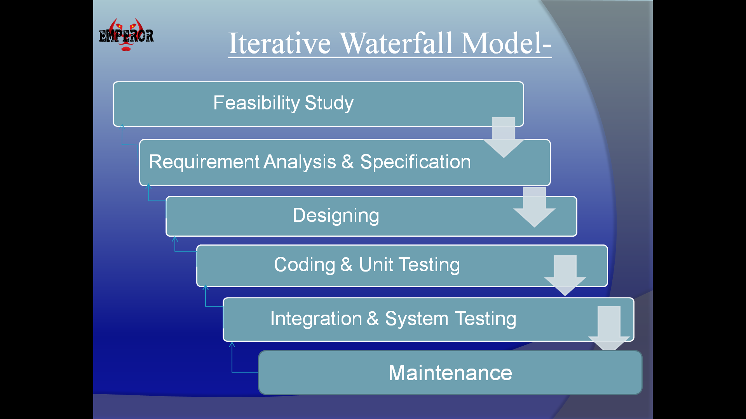

Fig.3.3.1. Phases of Iterative Waterfall Model

This iterative approach supports a *product* rather than a *project* mindset. This provides greater flexibility throughout the development process; whereas on projects the requirements are defined and locked down from the very beginning, making it difficult to change them later. Iterative product development allows the software to evolve in response to changes in business environment or market requirements. Because of the short iteration style of agile software development, it also has strong connections with the lean startup concept.

`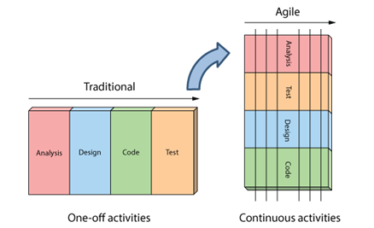

Fig.3.3.2.Iterative vs. waterfall

## 3.4 Agile Model - Pros and Cons

Agile methods are being widely accepted in the software world recently. However, this method may not always be suitable for all products. Here are some pros and cons of the agile model.

The advantages of the Agile Model are as follows −

* Is a very realistic approach of software development.
* Promotes teamwork and cross training.
* Functionality can be developed rapidly and demonstrated.
* Resource requirements are minimum.
* Suitable for fixed or changing requirements
* Delivers early partial working solutions.
* Good model for environments that change steadily.
* Minimal rules, documentation easily employed.
* Enables concurrent development and delivery within an overall planned context.
* Little or no planning required.
* Easy to manage.
* Gives flexibility to developers.

The disadvantages of the Agile Model are as follows −

* Not suitable for handling complex dependencies.
* More risk of sustainability, maintainability and extensibility.
* An overall plan, an agile leader and agile PM practice is a must without which it will not work.
* Strict delivery management dictates the scope, functionality to be delivered, and adjustments to meet the deadlines.
* Depends heavily on customer interaction, so if customer is not clear, team can be driven in the wrong direction.
* There is a very high individual dependency, since there is minimum documentation generated.
* Transfer of technology to new team members may be quite challenging due to lack of documentation.

**3.5Burn-down Chart**

The burn-down is a chart that shows how quickly you and your team are burning through your customer’s user stories. It shows the total effort against the amount of work we deliver each iteration.

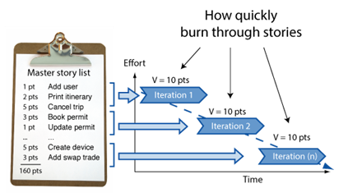

Fig.3.5.1. Working of Iterations

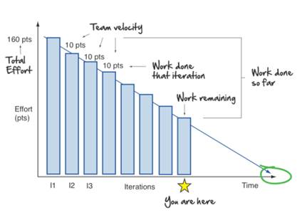

Fig.3.5.2.Ideal Burn Down Graph

We can see the total effort on the left, our team velocity on the right. But look what else this simple graphs gives us.

* Work done each iteration
* Work remaining
* Work done so far
* When we can expect to be done

All this from one graph!

Now what you see above is pretty ideal. A more realistic burn-down looks something like this: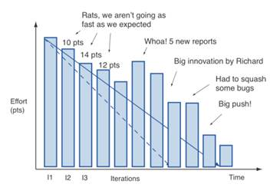

Fig.3.5.3. Realistic Burn Down Graph

It’s never a straight line. The team never moves at exactly one fixed velocity. And we discover things along the way (notice how it shows us scope creep in the form of those 5 new reports).

And of course like all things in Agile, you are free to make things your own. One tweak I like making to the burn-down is displaying total work done each iteration also. This lets me look at the chart, and immediately get a sense of whether we are a quarter, a third, or ½ way done the project.

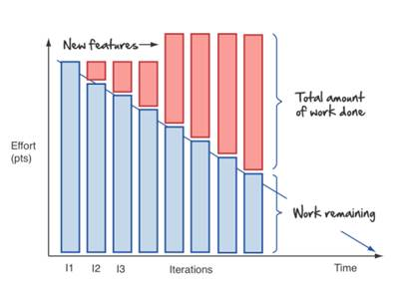  
Fig.3.5.4. Explanation

# **3.6 User Stories**

User stories are features our customers might one day like to see in their software.

User stories are like agile requirements except that they’re not. For one there’s no guarantee all these features are going to make it into the final version of the software. Secondly, Agilest know

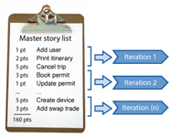

Fig.3.6.1. Iteration level

their customers are going to change their mind - and that’s OK.

Typically no more than a couple days work, they form the basis of our agile plans.

User stories form the basis of the agile plan. They are sized and prioritized like any other wish list. You simply start at the top and work your way down. Nothing big or complex. Just a prioritized to do list and a desire to get things done.

We get them by sitting down with our customers and asking lots of questions.

Big rooms with lots of white space to draw are great for gathering user stories. In these story gathering workshops we draw lots of pictures (flowcharts, screens, storyboards, and mockups, anything that helps) and break the functionality down into simple easy to understand words and phrases our customers understand. User stories!

**CHAPTER-4**

**DETAILS OF TECHNOLOGIES USED**

**4.1 .NET**

.NET Framework (pronounced as "dot net") is a software framework developed by Microsoft that runs primarily on Microsoft Windows. It includes a large class library named as Framework Class Library (FCL) and provides language interoperability (each language can use code written in other languages) across several programming languages. Programs written for .NET Framework execute in a software environment (in contrast to a hardware environment) named the Common Language Runtime (CLR). The CLR is an application virtual machine that provides services such as security, memory management, and exception handling. As such, computer code written using .NET Framework is called "managed code". FCL and CLR together constitute the .NET Framework.

FCL provides user interface, data access, database connectivity, cryptography, web application development, numeric algorithms, and network communications. Programmers produce software by combining their source code with .NET Framework and other libraries. The framework is intended to be used by most new applications created for the Windows platform. Microsoft also produces an integrated development environment largely for .NET software called Visual Studio.

.NET Framework began as proprietary software, although the firm worked to standardize the software stack almost immediately, even before its first release. Despite the standardization efforts, developers, mainly those in the free and open-source software communities, expressed their unease with the selected terms and the prospects of any free and open-source implementation, especially regarding software patents. Since then, Microsoft has changed .NET development to more closely follow a contemporary model of a community-developed software project, including issuing an update to its patent promising to address the concerns.

.NET Framework led to a family of .NET platforms targeting mobile computing, embedded devices, alternative operating systems, and web browser plug-ins. A reduced version of the framework, .NET Compact Framework, is available on Windows CE platforms, including Windows Mobile devices such as smartphones. .NET Micro Framework is targeted at very resource-constrained embedded devices. Silverlight was available as a web browser plugin. Mono is available for many operating systems and is customized into popular smartphone operating systems (Android and iOS) and game engines. .NET Core targets the Universal Windows Platform (UWP).

**4.2 Hibernate(framework)**

Hibernate ORM (Hibernate in short) is an object-relational mapping tool for the Java programming language. It provides a framework for mapping an object-oriented domain model to a relational database. Hibernate solves object-relational impedance mismatch problems by replacing direct, persistent database accesses with high-level object handling functions.

Hibernate is free software that is distributed under the GNU Lesser General Public License 2.1.

Hibernate's primary feature is mapping from Java classes to database tables, and mapping from Java data types to SQL data types. Hibernate also provides data query and retrieval facilities. It generates SQL calls and relieves the developer from the manual handling and object conversion of the result set.

The mapping of Java classes to database tables is implemented by the configuration of an XML file or by using Java Annotations. When using an XML file, Hibernate can generate skeleton source code for the persistence classes. This is auxiliary when annotations are used. Hibernate can use the XML file or the Java annotations to maintain the database schema.

There are provided facilities to arrange one-to-many and many-to-many relationships between classes. In addition to managing associations between objects, Hibernate can also manage reflexive associations wherein an object has a one-to-many relationship with other instances of the class type.

Hibernate supports the mapping of custom value types. This makes the following scenarios possible:

* Overriding the default SQL type when mapping a column to a property.
* Mapping Java Enums to columns as though they were regular properties.
* Mapping a single property to multiple columns.

**4.3 Java Scripts**

JavaScript often abbreviated as "JS", is a high-level, dynamic, un-typed, and interpreted run-time language. It has been standardized in the ECMAScript language specification. Alongside HTML and CSS, JavaScript is one of the three core technologies of World Wide Web content production; the majority of websites employ it, and all modern Web browsers support it without the need for plug-ins. JavaScript is prototype-based with first-class functions, making it a multi-paradigm language, supporting object-oriented, imperative, and functional programming styles. It has an API for working with text, arrays, dates and regular expressions, but does not include any I/O, such as networking, storage, or graphics facilities, relying for these upon objects made available by the host environment in which it is embedded.

Although there are strong outward similarities between JavaScript and Java, including language name, syntax, and respective standard libraries, the two are distinct languages and differ greatly in their design. JavaScript was influenced by programming languages such as Self and Scheme.

JavaScript is also used in environments that are not Web-based, such as PDF documents, site-specific browsers, and desktop widgets. Newer and faster JavaScript virtual machines (VMs) and platforms built upon them have also increased the popularity of JavaScript for server-side Web applications. On the client side, developers have traditionally implemented JavaScript as an interpreted language, but more recent browsers perform just-in-time compilation. Programmers also use JavaScript in video-game development and in desktop and mobile applications.

**4.4 AngularJS**

AngularJS is a JavaScript-based open-source front-end web application framework mainly maintained by Google and by a community of individuals and corporations to address many of the challenges encountered in developing single-page applications. The AngularJS framework works by first reading the HTML page, which has embedded into it additional custom tag attributes. Angular interprets those attributes as directives to bind input or output parts of the page to a model that is represented by standard JavaScript variables. The values of those JavaScript variables can be manually set within the code, or retrieved from static or dynamic JSON resources.

AngularJS's design goals include:

* to decouple DOM manipulation from application logic. The difficulty of this is dramatically affected by the way the code is structured.
* to decouple the client side of an application from the server side. This allows development work to progress in parallel, and allows for reuse of both sides.
* to provide structure for the journey of building an application: from designing the UI, through writing the business logic, to testing.

Angular implements the MVC pattern to separate presentation, data, and logic components. Using dependency injection, Angular brings traditionally server-side services, such as view-dependent controllers, to client-side web applications. Consequently, much of the burden on the server can be reduced.

**4.5 Bootstrap**

**Bootstrap** is a [free and open-source](https://en.wikipedia.org/wiki/Free_and_open-source_software) front-end [web framework](https://en.wikipedia.org/wiki/Web_framework) for designing [websites](https://en.wikipedia.org/wiki/Website) and [web applications](https://en.wikipedia.org/wiki/Web_application). It contains [HTML](https://en.wikipedia.org/wiki/HTML)- and [CSS](https://en.wikipedia.org/wiki/CSS)-based design templates for [typography](https://en.wikipedia.org/wiki/Typography), forms, buttons, navigation and other interface components, as well as optional [JavaScript](https://en.wikipedia.org/wiki/JavaScript) extensions. Unlike many web frameworks, it concerns itself with [front-end development](https://en.wikipedia.org/wiki/Front-end_web_development) only.

**4.6 HTML**

Hypertext Markup Language (HTML) is the standard markup language for creating web pages and web applications. With Cascading Style Sheets (CSS) and JavaScript it forms a triad of cornerstone technologies for the World Wide Web. Web browsers receive HTML documents from a webserver or from local storage and render them into multimedia web pages. HTML describes the structure of a web page semantically and originally included cues for the appearance of the document.

HTML elements are the building blocks of HTML pages. With HTML constructs, images and other objects, such as interactive forms, may be embedded into the rendered page. It provides a means to create structured documents by denoting structural semantics for text such as headings, paragraphs, lists, links, quotes and other items. HTML elements are delineated by tags, written using angle brackets. Tags such as <img /> and <input /> introduce content into the page directly. Others such as <p>...</p> surround and provide information about document text and may include other tags as sub-elements. Browsers do not display the HTML tags, but use them to interpret the content of the page.

HTML can embed programs written in a scripting language such as JavaScript which affect the behavior and content of web pages. Inclusion of CSS defines the look and layout of content. The World Wide Web Consortium (W3C), maintainer of both the HTML and the CSS standards, has encouraged the use of CSS over explicit presentational HTML since 1997.

**4.7 CSS**

Cascading Style Sheets (CSS) is a style sheet language used for describing the presentation of a document written in a markup language. Although most often used to set the visual style of web pages and user interfaces written in HTML and XHTML, the language can be applied to any XML document, including plain XML, SVG and XUL, and is applicable to rendering in speech, or on other media. Along with HTML and JavaScript, CSS is a cornerstone technology used by most websites to create visually engaging webpages, user interfaces for web applications, and user interfaces for many mobile applications.

CSS is designed primarily to enable the separation of presentation and content, including aspects such as the layout, colors, and fonts. This separation can improve content accessibility, provide more flexibility and control in the specification of presentation characteristics, enable multiple HTML pages to share formatting by specifying the relevant CSS in a separate .css file, and reduce complexity and repetition in the structural content.

**CHAPTER-5**

**SYSTEM REQUIREMENTS**

**5.1Hardware Requirements:**

* System    :   Pentium IV 2.4 GHz or above.
* Resolution : Minimum 800X600
* Hard Disk  :   Minimum 40 GB.
* Monitor   :   15 VGA Color.
* RAM    :   Minimum 256 MB.

**5.2Software Requirements:**

* Operating system   : Windows 10.
* RAM    :   Minimum 256 MB.
* IDE : Microsoft Visual Stdio.
* Database Server : Sql Server 2005
* Web Server : Apache Tomcat 7.0

**5.3 Functional Requirement**

The Functional Requirements in this document are prioritized as follows:

* When the user clicks on the registration link, system should re-direct to registration form and provide two options: Register as Patient and Register as Doctor.
* User to fill the basic attributes: First Name, Last Name, Age, Gender, Contact Number, User Id and Password and Clicking ‘Submit’ button should validate the datatype constraints for each field.
* User failing to provide information for the mandatory fields be presented with an alert message – ‘Please update the highlighted mandatory field(s).’ Also, highlight the missed out field in red.
* Post-successful field validation, save the information in the database.
* A registered user – is able click ‘Login’ link, after keying in ‘UserID’ & ‘Password’ field and get his credentials authenticated with the existing database entry.
* If a registered user – is unable to login and get his credentials authenticated, The user is presented with relevant error messages: Invalid User ID (or) Incorrect Password.
* Once the user is successfully logged in, gets the Search page displayed.
* User is able to search for a doctor or a clinic using the search text field in the embedded google maps search pane and the Search results should be displayed in the maps.
* Clicking “Advanced Search” should display a form with below fields: Keyword Search, Name, Specialization, City
* The display form should have buttons to “Submit Search” or “Reset” the fields.
* Clicking on a particular profile should display the details as: Doctor Name, Specialization, City, Availability.
* User to choose the Doctor’s availability and click “Schedule Appointment”.
* Ability of the portal to allow the users to chat with the Doctors based on their availability to solve any queries.
* Portal to display a form that allows user to report the technical issues through emails.

**5.4 Non-functional Requirement**

* AVAILABLITY - This application is available online.
* RELIABLITY - This application works same according to documentation.
* FLEXIBLITY - This application works on and above every platform.
* SECURITY -This application uses the credentials to authenticate the user databases.

**CHAPTER-6**

**DESIGN**

**6.1 MODULE**

**6.1.1 Module 1: As an User**

|  |
| --- |
| As a user I should be able to sign-up and create a new account so I can avail the services of the portal using the sign-up page. |
| As a user I should be able to log-in using the login-page of the portal so I can access my account. |
| As a user I should be able to access the schedule of the examination so I that I can know the dates of the exams I am interested in. |
| As a user I should be able to access some general information related to the examination so that I can be aware of the information without signing-up or logging-in |
| As a user I should be able to apply for exams so I can eliminate the manual process of applying. |
| As a user I should be notified about the upcoming exams which I have enrolled for so I can be aware of the same. |
| As a user I should be able to access my result so I don't have to rely on manual methods. |
| As a user I should be able to pay for my exams using the portal so that I can perform cashless transactions from my home. |
| As a user I should be able to register myself for retests so I can appear for the examination again. |
| As a user I am able to download the previous year papers from Examination Portal |
| As a user I am able to give feedback about the examination portal to the admin |
| As a user , I should receive mails for any modifications in exam schedule. |

**6.1.2 Module 2: As a Admin**

|  |
| --- |
| As an administrator I should be able to log in with my credentials so I can administrate the portal. |
| As an administrator I should be able to add/modify the exam schedule so the registered users are updated of the changes and new additions in the exam schedule . |
| As an administrator I should be able to add/modify the information which will be displayed on the portal's homepage and is accessible by everyone who visits the portal(home page) |
| As an administrator I should be able to provide notifications to users so they are aware of the schedule. |
| As an administrator I should be able to provide results to the user so they can access it and skip the delay in accessing the manual result. |
| As an administrator I should be able to check the payment status and decide whether the user can appear for the exam or not so that only through successful registration a user can appear. |
| As an administrator I should be able to manage the schedule of retests so that users can register accordingly. |
| As an administrator I should be able to add study materials on the Examination Portal |
| As an administrator I should be able to view the feedback provided by the users. |

**CHAPTER-7**

**SNAPSHOTS**

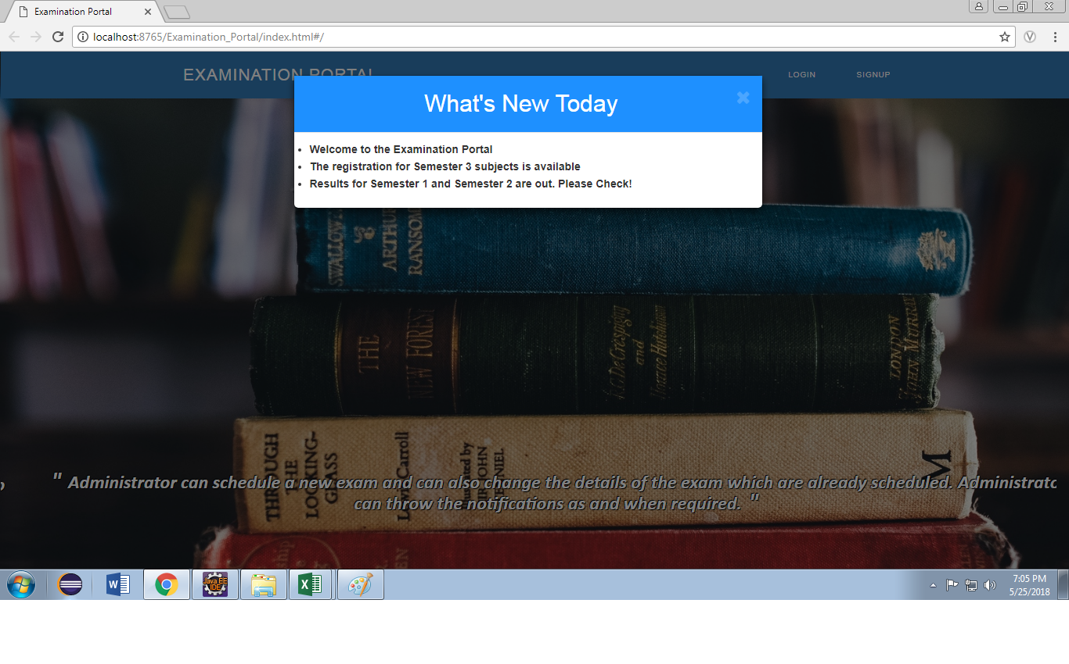Fig.7.1 Home Page

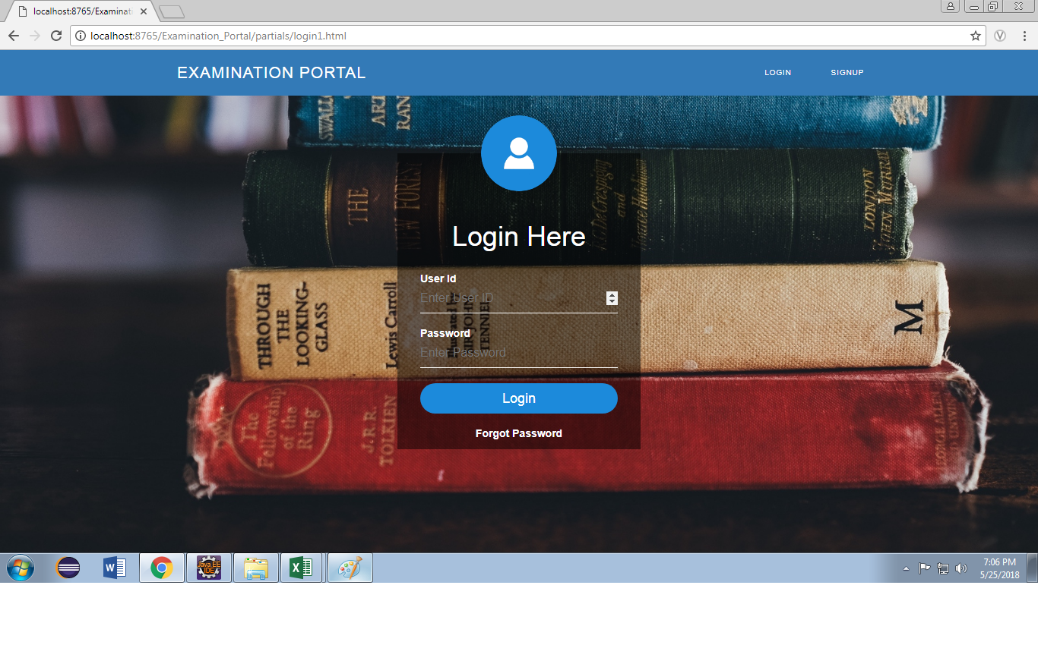

Fig.7.3. Login Page

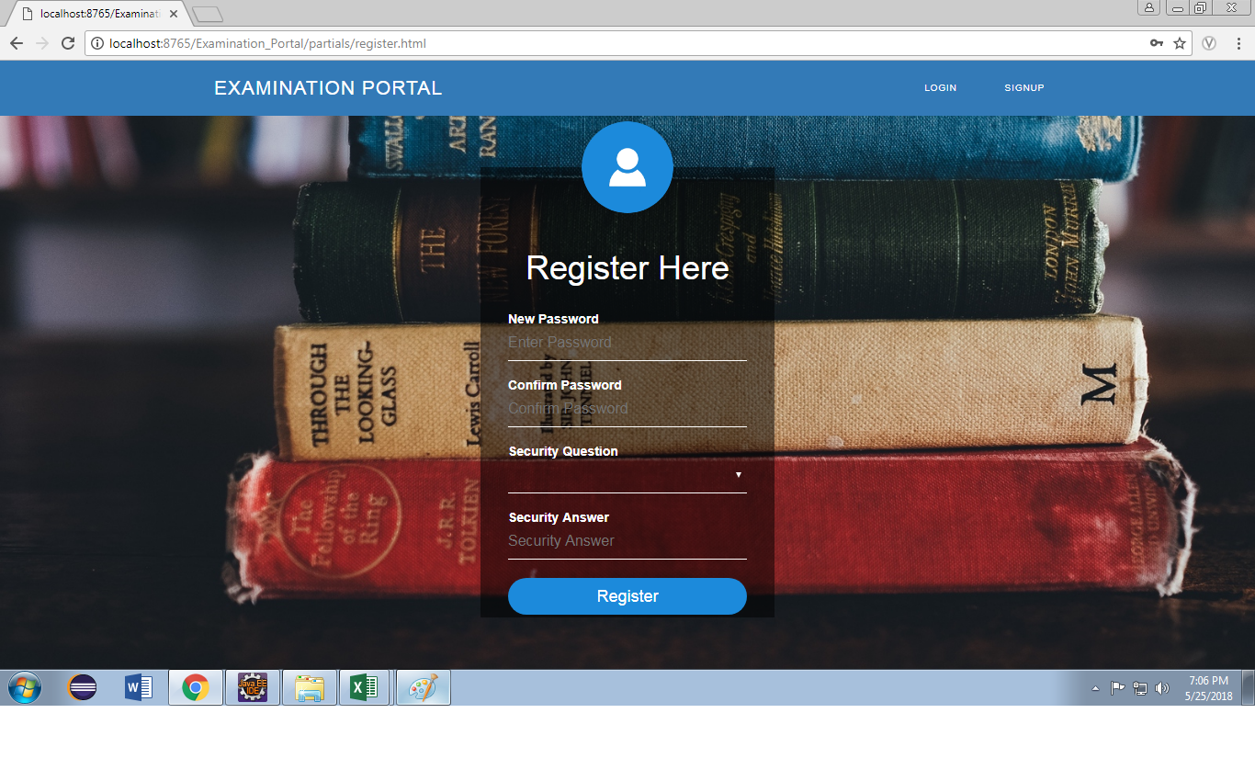

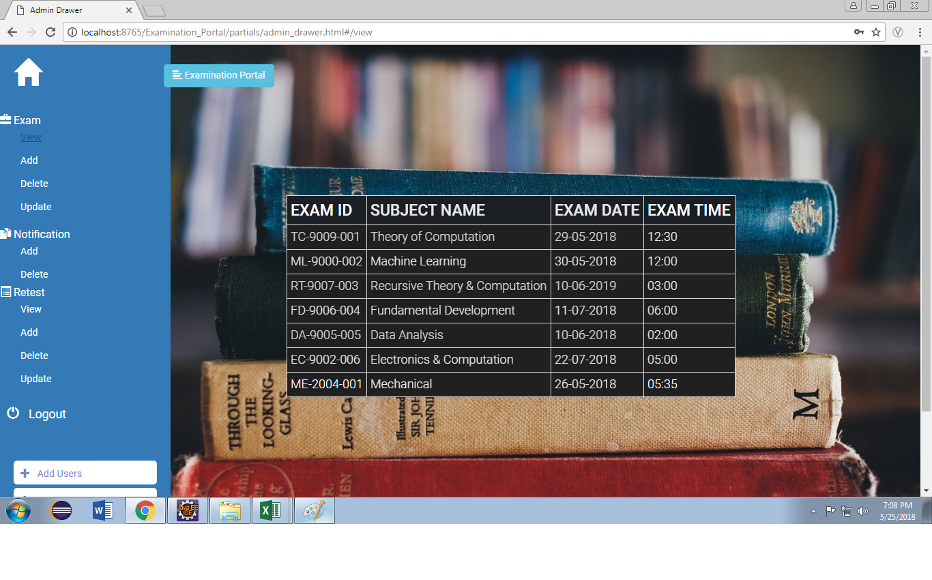

Fig.7.4.View Exam

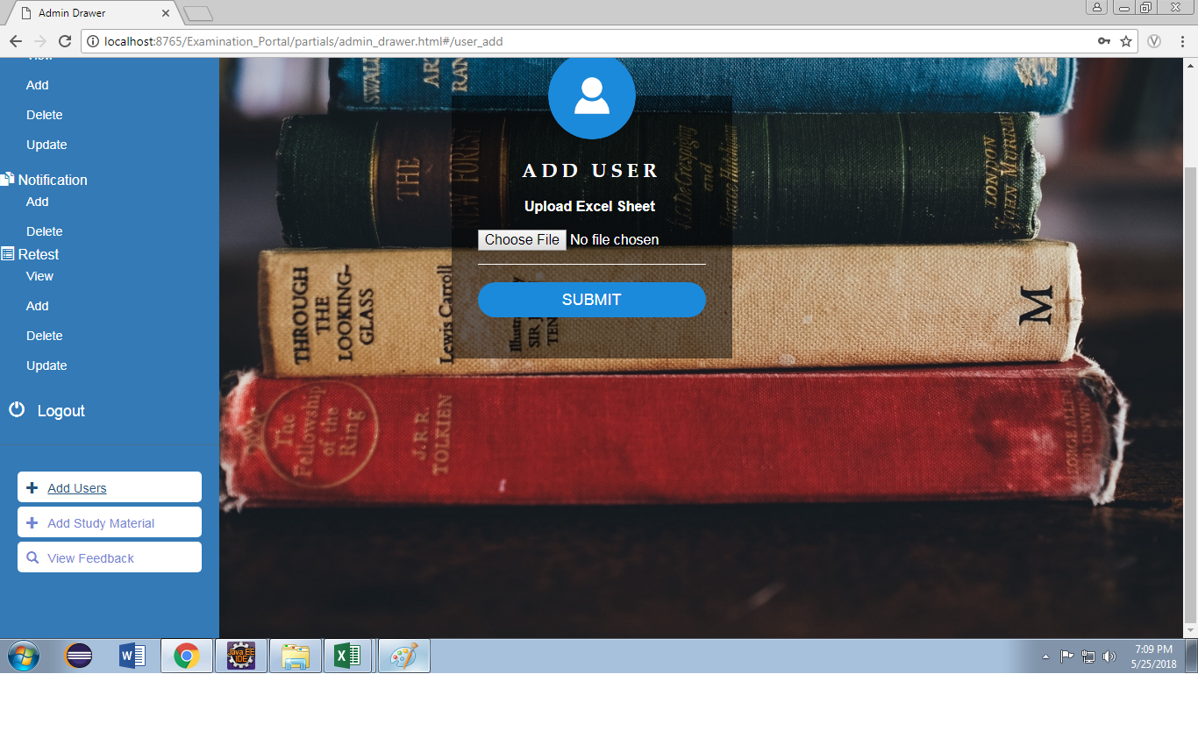

Fig.7.5. Add User

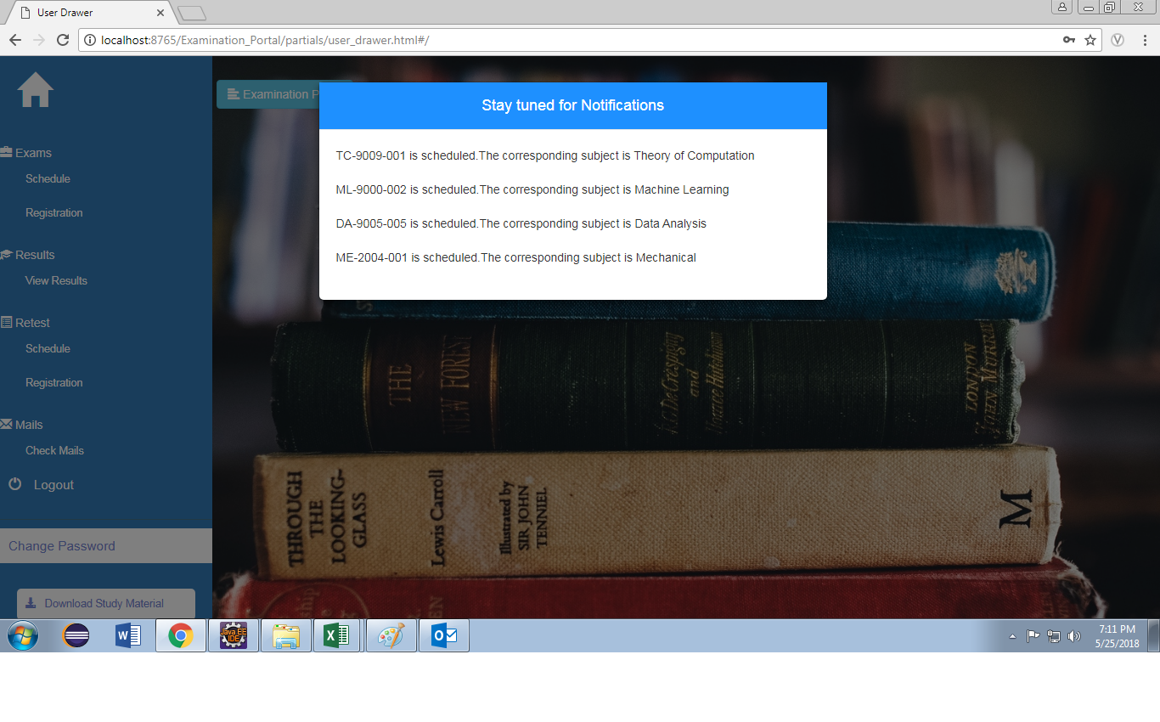

Fig.7.6. User HomePage

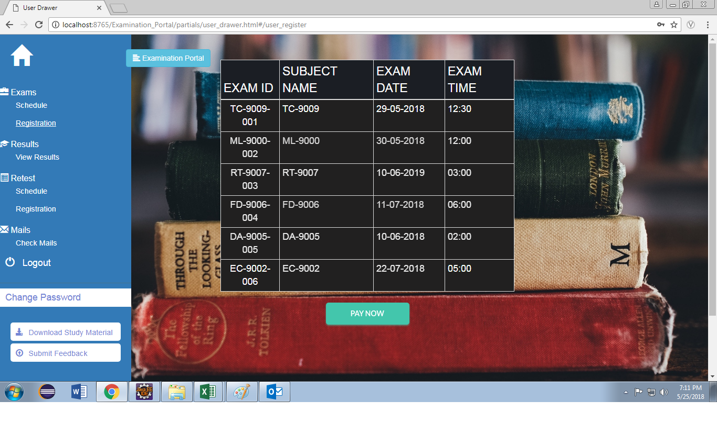

Fig.7.7. Register for Exams

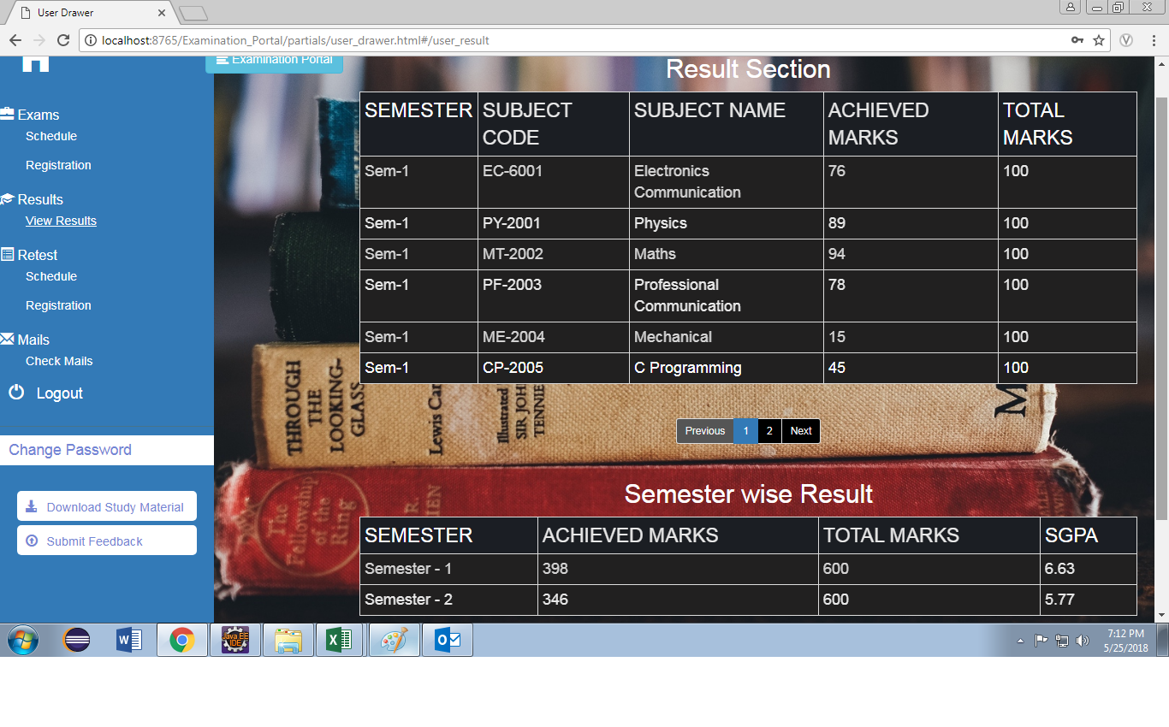

Fig.7.8.View Results

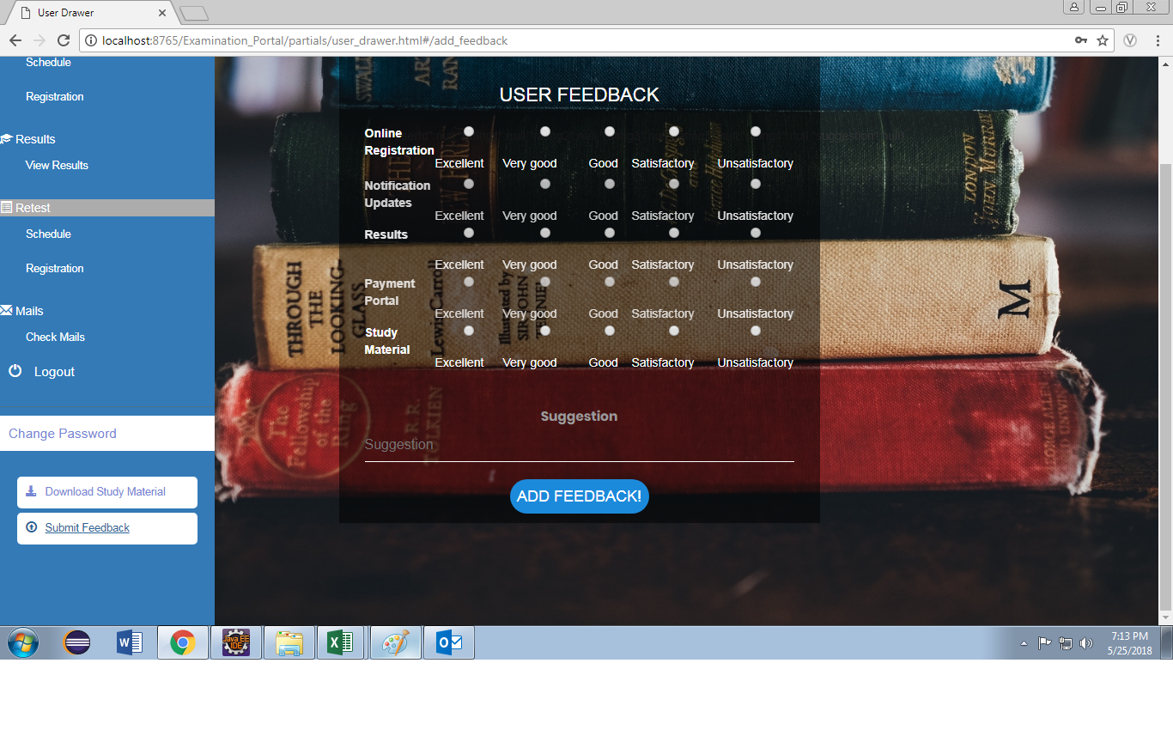

Fig.7.9 Feedback

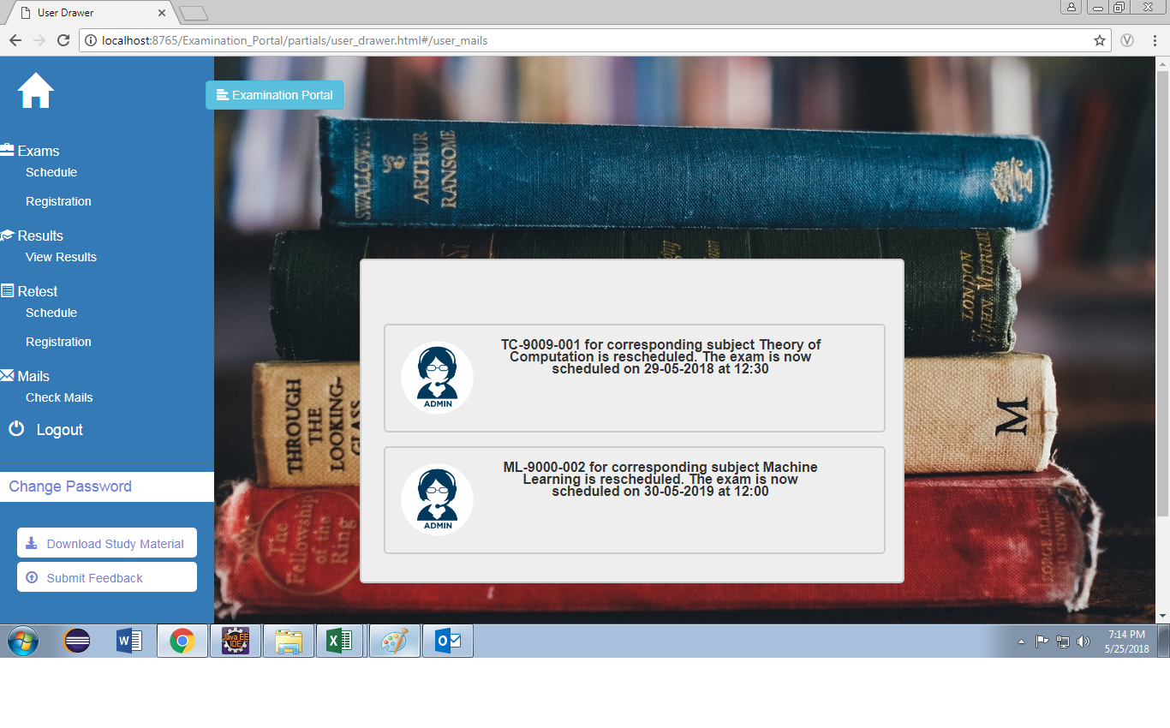

**CHAPTER-8**

**TESTING & DEBUGGING**

**8.1 Introduction**

The development of software system involves a series of production activities, where the opportunity for the injection of human fallibilities is enormous. Errors may begin to occur at the very inception of the process of where the objectives may be erroneously on imperfectly specified as well as later design and development stages. Because of human inability to perform and communicate with perfection, software is accompanied by quality assurance activity.

In many ways testing is an individual elastic process and the number of different types of lists varies is much as the different development approaches. For many years, our only defense against programming errors was careful design and the native and intelligence of the programmer. We are now in era in which modern design techniques enable us to reduce the number of initial errors that are inherent in the code.

Similarly, different test methods are beginning to cluster themselves into several distinct approaches and philosophies. Testing is a critical phase in system implementation. Testing of system involves hardware devices testing and debugging of computer programs and testing information processing procedures. Testing can be done with the test data which attempts to simulate all possible condition that may arise during processing. If Structured programming methodologies have been adopted during coding, the testing proceeds from the higher to the lower level of programming modules until entire program is tested.

**CHAPTER-9**

**TYPES OF TESTING**

**9.1 Black Box Testing**

Internal system design is not considered in this type of testing. Tests are based on requirements and functionality.

**9.2 White-Box Testing**

This testing is based on knowledge of the internal logic of an application’s code. Also known as Glass box Testing. Internal software and code working should be known for this type of testing. Tests are based on coverage of code statements, branches, paths, conditions.

**9.3 Unit Testing**

Testing of individual software components or modules. Typically done by the programmer and not by testers, as it requires detailed knowledge of the internal program design and code may require developing test driver modules or test harnesses.

**9.4 Incremental Integration Testing**

Bottom up approach for testing i.e. continuous testing of an application as new functionality is added; Application functionality and modules should be independent enough to test separately done by programmers or by testers.

**9.5 Integration testing**

Testing of integrated modules to verify combined functionality after integration. Modules are typically code modules, individual applications, client and server applications on a network, etc. This type of testing is especially relevant to client/server and distributed systems.

**9.6 Functional Testing**

This type of testing ignores the internal parts and focus on the output is as per requirement or not. Black-box type testing geared to functional requirements of an application.

**9.7 SystemTesting**

Entire system is tested as per the requirements. Black-box type testing that is based on overall requirements specifications, covers all combined parts of a system.

**9.8 EndTo End Testing**

Similar to system testing, involves testing of a complete application environment in a situation that mimics real-world use, such as interacting with a database, using network communications, or interacting with other hardware, applications, or systems if appropriate.

**9.9 Regression Testing**

Testing the application as a whole for the modification in any module or functionality. Difficult to cover all the system in regression testing so typically automation tools are used for these testing types.

**9.10Acceptance Testing**

Normally this type of testing is done to verify if system meets the customer specified requirements. User or customer do this testing to determine whether to accept application.

**9.11 Load Testing**

It is a performance testing to check system behavior under load. Testing an application under heavy loads, such as testing of a web site under a range of loads to determine at what point the system’s response time degrades or fails.

**9.12 Test Cases**

The primary objective of test case design is to derive a set of tests that have the highest likelihood of uncovering errors in software. The test case specification is the major activity in the testing process. Careful selection of test cases that satisfy the criterion on approach specified is essential for proper testing. Various characteristics of test cases that are required for portal are:

A good test has a high probability of finding an error. A good test is not redundant. A good test should be “Best of Breed”. A good test should be neither too simple not too complex.

Test Data for This Application:

1. User Details like Name, Employee-ID, etc.

2. Project Details like hands-On, objective, subject-wise, exam-wise, etc.

**CHAPTER-10**

**CONCLUSION AND FUTURE WORK**

**CONCLUSION**

Such an application created which is concise and supported in every operating system. Thus there is scope for backward compatibility.

The web-app minimizes resource consumption on the system and aims to be efficient and fast.

To improve the user friendliness the app uses a simple user interface, thus ensuring maximum possible accessibility.

**SCOPE OF FUTURE WORK**

There are some features which can be implemented further.

* Redesigning the Database Structure and making it more advanced.
* With a bigger team the project can be implemented using advanced JavaScript frameworks.
* Increasing the scalability of the application so that many users can use it simultaneously.

**REFERENCES**

* [www.stackoverflow.com](http://www.stackoverflow.com/)
* www.w3schools.com
* [www.github.com](http://www.github.com)
* http://info.dogpile.com/dogpl.305.10/search/web?fcoid=417&fcop=topnav&fpid=2&cid=319942383&ad.segment=dogpl.305.10&ad.device=c&aid=a477e374-d859-4803-8b88-c87f836344b9&ridx=1&q=e+survey+functional+requirements&ql=&ss=t
* "Supplement 4-A, A **Procedure** for Requirements Analysis". [Systems Engineering Fundamentals](http://www.dau.mil/publications/publicationsDocs/SEFGuide%2001-01.pdf) (PDF). United States Government US Army. 2001. [ISBN](https://en.wikipedia.org/wiki/International_Standard_Book_Number) [978-1484120835](https://en.wikipedia.org/wiki/Special:BookSources/978-1484120835). Retrieved 18 March 2016.
* Roman, G.-C. (1985) "A taxonomy of current issues in requirements engineering" Computer, April 1985 Volume: 18 Issue: 4, pp. 14–23, [ISSN](https://en.wikipedia.org/wiki/International_Standard_Serial_Number) [0018-9162](https://www.worldcat.org/search?fq=x0:jrnl&q=n2:0018-9162).
* R. T. Yeh (1982) "Requirements Analysis- A Management Perspective," Proc. COMPSAC '82, Nov. 1982, pp. 410–416.
* Wiegers, Karl E. (2003). [Software Requirements](http://processimpact.com/pubs.shtml#reqs) (2nd ed.). Redmond: Microsoft Press. [ISBN](https://en.wikipedia.org/wiki/International_Standard_Book_Number) [978-0-7356-1879-4](https://en.wikipedia.org/wiki/Special:BookSources/978-0-7356-1879-4).
* Stellman, Andrew; Greene, Jennifer (2005). [Applied Software Project Management](http://www.stellman-greene.com/) (1st ed.). Cambridge, MA: O'Reilly Media. [ISBN](https://en.wikipedia.org/wiki/International_Standard_Book_Number) [978-0-596-00948-9](https://en.wikipedia.org/wiki/Special:BookSources/978-0-596-00948-9).
* [Sommerville, Ian](https://en.wikipedia.org/wiki/Ian_Sommerville_(academic)) (2006). [Software Engineering](http://www.cs.st-andrews.ac.uk/~ifs/Books/SE8/index.html) (8th ed.). [ISBN](https://en.wikipedia.org/wiki/International_Standard_Book_Number) [978-0-321-31379-9](https://en.wikipedia.org/wiki/Special:BookSources/978-0-321-31379-9).

The Complete Reference JAVA – Herbert Schildt